- Draw a simple diagram (hand-drawn or digital) showing how your phone connects to Instagram, including your device, WiFi router, ISP, and Instagram server. Label each part and the connections.

- 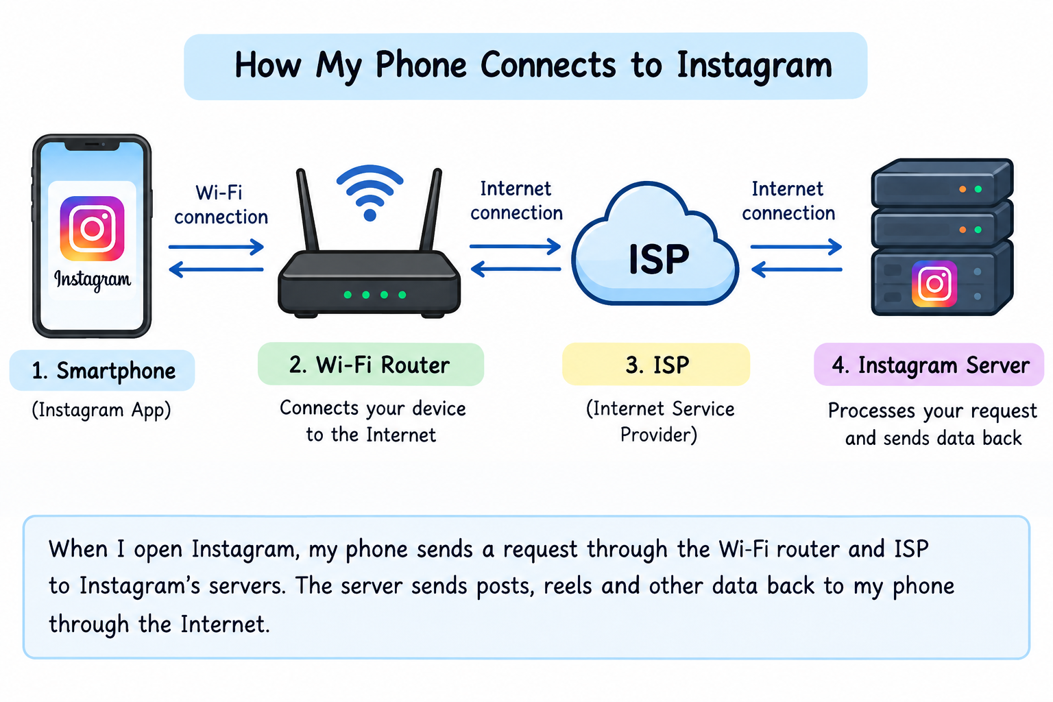

- List 5 devices you use or see daily that are part of a network (for example: smartphone, smart TV, WiFi router, laptop, smartwatch). For each, write what type of network it connects to (LAN, WAN, PAN, etc.).

No. | Device | Type of Network | Use
1 | Smartphone | WAN / WLAN | Connects to the internet using mobile data or Wi-Fi.
2 | Laptop | LAN / WLAN | Connects to a local network using Ethernet or Wi-Fi.
3 | Smart TV | WLAN | Connects to Wi-Fi to stream videos.
4 | Wi-Fi Router | LAN / WAN | Connects local devices and provides internet access.
5 | Smartwatch | PAN | Connects to a smartphone using Bluetoo

- Explain the difference between the Internet and an intranet using an example from your college or a public WiFi you have used.

:- Internet vs Intranet
Internet | Intranet
The Internet is a global network accessible to everyone. | An intranet is a private network used by an organization.
Example: Using Google or YouTube on public Wi-Fi. | Example: A college's private portal used by students and teachers to access attendance, results, and notices.
It can be accessed by anyone with an internet connection. | It is accessible only to authorized users.

- Pick any one app you use (like WhatsApp, Zomato, or Flipkart) and describe, in 4-5 lines, how data travels from your device to their server and back when you perform a search inside the app.<br><br><em><strong>Hint:</strong> Mention the devices and networks involved, and what happens when you hit 'search'.</em>

- Example: WhatsApp Search
- When I open WhatsApp on my smartphone and type a name in the search bar, my phone processes the search request.
- The data travels through Wi-Fi or mobile data to my Internet Service Provider (ISP).
- The ISP sends the request through the Internet to WhatsApp’s server.
- The server processes the request and sends the relevant search results back through the Internet and ISP to my phone.
- WhatsApp displays the results on my screen, allowing me to find the required chat or message.

